Main goal: using the provided service to send the updated data (battery level, heart rate) through BLE stack.

Key word for search: battery service, heart rate service.

Method: create and initialize service instance, applied in the timeout function in “timer”.

1)define service instance:



Something not clear yet; creating UUID?

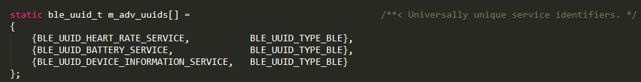

2)initialize the service:

First, build a battery service init structure, which would contain all options and data needed for initialization of the service.

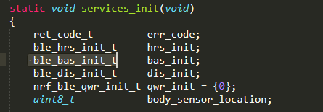

Second, give the needed information to that created structure and initialize the service by using function “ble_bas_init”.

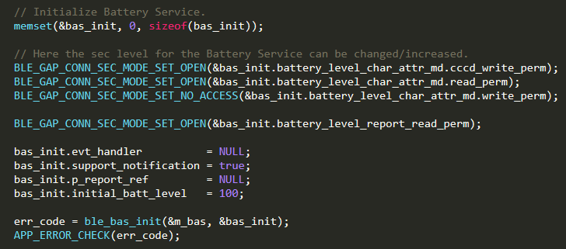

The middle part might be used to determine the read and write ability of that service.

Potential expansion: the “bas_init.evt_handler”, which can be used to perform specific function when the battery level in some specific situation.

3)applied in the battery level timeout handler:



That function would send the updated data through the BLE stack.

4)don’t forget to include the service initialize function into the main function:



Key note: To use the service:

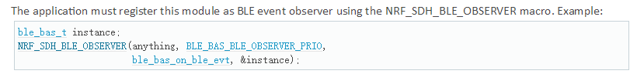

Which would be in the “ble_stack_init” in this case.